Grosse Ile Yacht Club Day Race 2024
SAILING INSTRUCTIONS (SIs)
Saturday, May 25th 2024
Last edited on May 24th, 2024

'[DP]' at the beginning of an SI if that SI is subject to discretionary penalty
1 | RULES
1.1 | This race will be under the management Grosse Ile Yacht Club Race Committee, which will have full and final authority in establishing the race articles and in interpreting the rules.  The RACING RULES of SAILING (RRS), and the prescriptions of the US SAILING, except as modified by this program, will govern.
2 | CHANGES TO SAILING INSTRUCTIONS
2.1 | Any change to the sailing instructions will be posted before 09:00 on the day it will take effect, except that any change to the schedule of races will be posted by 20:00 on the day before it will take effect.
3 | COMMUNICATIONS WITH COMPETITORS
3.1 | Notices to competitors will be posted on the official notice board located at www.noticeofrace.net.
3.2 | On the water, the race committee intends to monitor and communicate with competitors via VHF radio on channel VHF CH71.
3.3 | [DP] While racing, except in an emergency, a boat shall not make voice or data transmissions and shall not receive voice or data communication that is not available to all boats.
4 | CODE OF CONDUCT
4.1 | [DP] Competitors and support persons shall comply with reasonable requests from race officials.
5 | SIGNALS MADE ASHORE
5.1 | Signals made ashore will be displayed at GIYC.
5.2 | When flag AP is displayed ashore, ‘1 minute’ is replaced with ‘not less than 60 minutes’ in Race Signals AP.
6 | SCHEDULE OF RACES
6.1 | The race will take place on Saturday May 25th, 2024. All participants are encouraged to attend the Skipper’s meeting at 09:00 on the morning of the race.
6.2 | The approximate time of the warning signal for the first start is 10:55. The starting sequence of classes is as follows:  Spinnaker A  Spinnaker B  JAM
6.3  6.4 | One race is scheduled and is required to be completed to constitute a series.  Afterglow will be located at the Grosse Ile Yacht Club Following the race.
7 | CLASS FLAGS
7.1 | The class flags are:  Spinnaker A – Blue  Spinnaker B – Green  Jam – Purple
8 | RACING AREA
8.1 | The racing area is North Western Lake Erie.  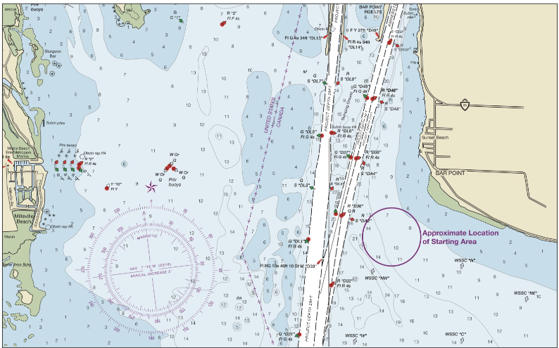
 | 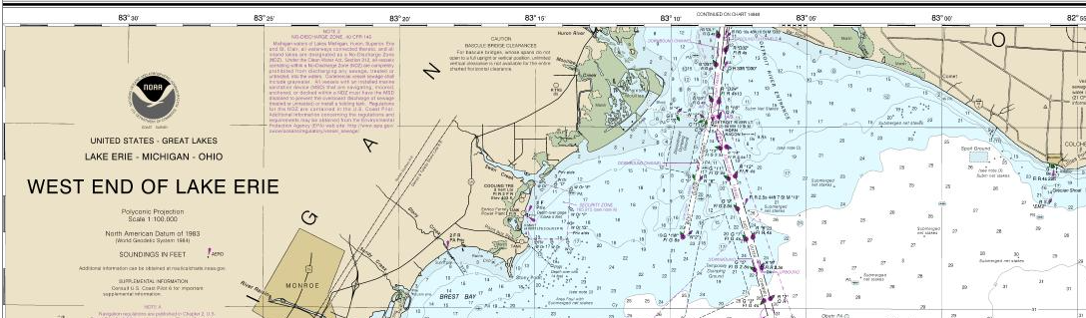
 | Chart 14830
9 | COURSES
9.1 | SI Addendum 1 show(s) the course(s), the order in which marks are to be passed, and the side on which each mark is to be left.
9.2 | No later than the warning signal, the race committee signal vessel will display the course to be sailed.
9.3 | Courses will not be shortened. This changes RRS 32.
9.4 | Legs of the course will not be changed after the preparatory signal. This changes RRS 33.
10 | MARKS
10.1 | Mark(s) are various fixed and or floating government buoys including…WSSC Marks, these marks have cylindrical form, white in color with orange reflective tape and an identification letter. The locations are listed below from the 2024 WSSC WNATR SIs.  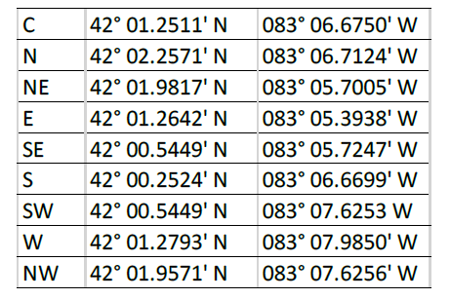  See USCG Light List for location and description of government buoys and aids to navigation  https://www.navcen.uscg.gov/light-list-annual-publication
10.2 | The following marks are rounding marks:  N. West Shore Sail Club North Mark  W. West Shore Sail Club West Mark  C. West Shore Sail Club Center Mark  S. West Shore Sail Club South Mark  CL. No:6870-Pelee Passage, Colchester Reef Light  DL. No:6885-Detroit River Entrance East Outer Channel, Detroit River Light  WO. No:7365-Detroit River Entrance West Outer Channel, Lighted Buoy 1W  EO. No:6895-Detroit River Entrance East Outer Channel, Light 1 E  T10. No:6935-Detroit River Entrance East Outer Channel, Light 10  EORN8. No:6925-East Outer Channel, Lighted Buoy 8
11 | THE START
11.1 | Races will be started using RRS 26.
11.2 | The starting line is between a staff displaying an orange flag on the signal vessel at the starboard end and the course side of the port-end starting mark (WSSC N).
11.3 | Boats whose warning signal has not been made shall avoid the starting area during the starting sequence for other races.
11.4 | If any part of a boat’s hull is on the course side of the starting line during the two minutes before her starting signal and she is identified, the race committee will attempt to broadcast her sail number on VHF channel VHF Ch71. Failure to make a broadcast or to time it accurately will not be grounds for a request for redress. This changes RRS 62.1(a).
11.5 | If any part of a boat’s hull is on the course side of the starting line at her starting signal and she is identified, the race committee will attempt to hail her sail number. Failure to hail her number, failure of her to hear such a hail, or the order in which boats are hailed will not be grounds for a request for redress. This changes RRS 62.1(a).
11.7 | A boat that does not start within 4 minutes after her starting signal will be scored Did Not Start without a hearing. This changes RRS A5.1 and A5.2.
12 | THE FINISH
12.1 | The finishing line is between an orange flag on the signal vessel at the port end and the course side of the starboard end finishing mark.
12.2 | If the race committee is absent when a boat finishes, she shall report her finishing time, and her position in relation to nearby boats, to the race committee at the first reasonable opportunity.
14 | PENALTY SYSTEM
14.1 | For the all class(es), RRS 44.1 is changed so that the Two-Turns Penalty is replaced by the One-Turn Penalty.
15 | TIME LIMITS [AND TARGET TIMES]
15.1 | The Mark 1 Time Limit, Race Time Limit (see RRS 35), and the Finishing Window are shown in the table below.  Mark 1 Time Limit from first start Race Time Limit Finishing Window after 1st boat finishes  2 hours 7.5 hours 2 hour
15.2 | If no boat has passed the first mark within the Mark 1 Time Limit, the race will be abandoned.
15.3 | The Finishing Window is the time for boats to finish after the first boat sails the course and finishes. Boats failing to finish within the Finishing Window, and not subsequently retiring, penalized or given redress, will be scored Time Limit Expired (TLE) without a hearing. A boat scored TLE shall be scored points for the finishing place [one][two] more than the points scored by the last boat that finished within the Finishing Window. This changes RRS 35, A5.1, A5.2 and A10.
15.4 | Failure to meet the Target Time will not be grounds for redress. This changes RRS 62.1(a).
16 | HEARING REQUESTS
16.1 | The protest time limit is 120 minutes after the last boat finishes the last race of the day or the race committee signals no more racing today, whichever is later. The time will be posted on the official notice board.
16.2 | Hearing request forms are available from the race office at https://www.ussailing.org/resource-library/us-sailing-hearing-request-form/
16.3 | Notices will be posted no later than 30 minutes after the protest time limit to inform competitors of hearings in which they are parties or named as witnesses. Hearings will be held in the protest room, located at GIYC, beginning at the time posted.
16.4 | RRS 62.2(a) and 66.2(a) do not apply.
17 | SCORING
17.1 | The scoring system is as follows:  As stated in the notice of Race, and RRS Appendix A, SCORING.
18 | SAFETY REGULATIONS
18.1 | [DP] A boat that retires from a race shall notify the race committee at the first reasonable opportunity.
19 | EQUIPMENT AND MEASUREMENT CHECKS
19.1 | A boat or equipment may be inspected at any time for compliance with the class rules, notice of race and sailing instructions.
20 | TRASH DISPOSAL
20.1 | Trash may be placed aboard official [or support person] vessels.
21 | PRIZES
21.1 | The number of flags will be dependent on the number of competitors per class.  1st place flag for 3-4 competitors  1st & 2nd for 5-6 competitors,  1st, 2nd & 3rd for 7 or more.  The Cannon Trophy (Best corrected -Spinnaker Fleet) and Warren Trophy (Best Corrected - JAM Fleet) will also be announced.  Flags will be awarded at the GIYC Awards Night in the fall.
22 | RISK STATEMENT
22.1 | RRS 3 states: ‘The responsibility for a boat’s decision to participate in a race or to continue to race is hers alone.’ By participating in this event each competitor agrees and acknowledges that sailing is a potentially dangerous activity with inherent risks. These risks include strong winds and rough seas, sudden changes in weather, failure of equipment, boat handling errors, poor seamanship by other boats, loss of balance on an unstable platform and fatigue resulting in increased risk of injury. Inherent in the sport of sailing is the risk of permanent, catastrophic injury or death by drowning, trauma, hypothermia or other causes.
23 | INSURANCE
23.1 | Each participating boat shall be insured with valid third-party liability insurance with a minimum cover of $300,000 per incident or the equivalent.

